# CS 255 System Design Document Template

This template lays out all the different sections that you need to complete for Project Two. Each section has guidance to prompt your thinking. You will need to continually reference the interview transcript as you work to make sure that you are addressing your client’s needs. There is no required length for the final document. Instead the goal is to complete each section based on what your client’s needs are. Remove this note when you are finished, and replace all bracketed text with the relevant information.

## UML Diagrams

### UML Use Case Diagram

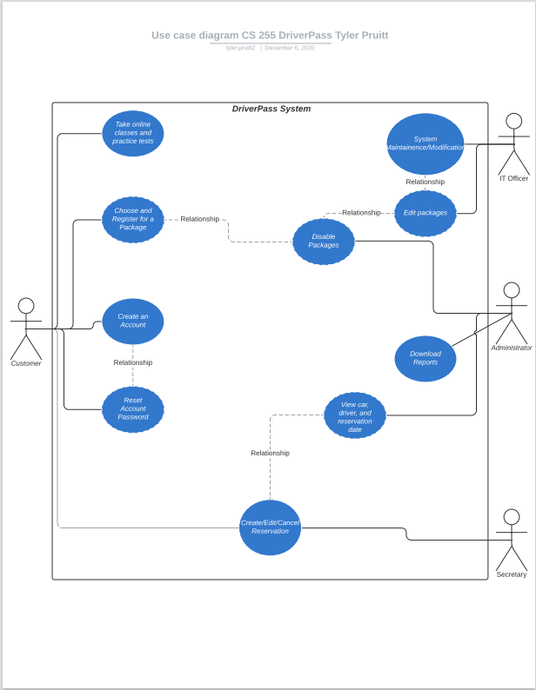

### UML Activity Diagrams

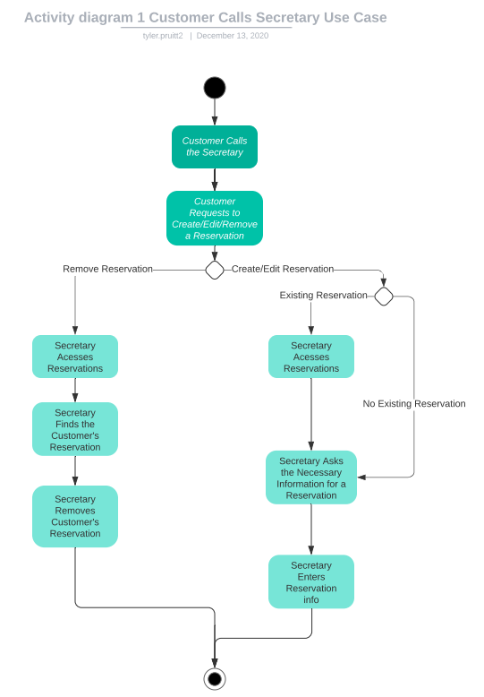

### 

### UML Sequence Diagram

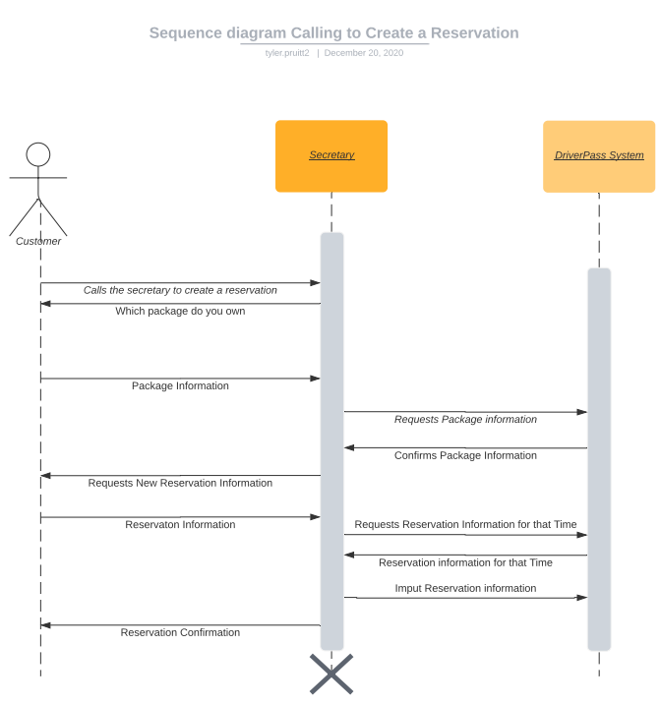

### UML Class Diagram

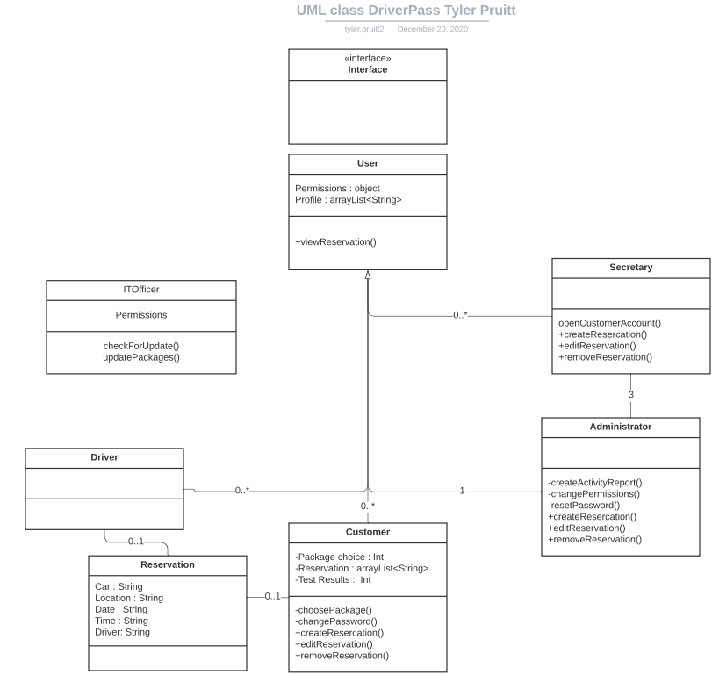

## Technical Requirements

The system is required to have several technical capabilities. Usage Analysis of the system was requested to be accessible by the administrator. They want to know who changed the system and when at any given time. The system is also required to have security, being stored in the cloud and having username and password to keep private information on accounts secure. The IT Officer needs the system to have serviceability as well. This includes pushing DMV updates, creating new packages, and more. While no specifics were specified, the system will need a certain level of availability. The same could be said about performance. All users as well as the IT officer needs authentication, and the system needs authorization capabilities in which the administrator should be in charge.

References

Chapter 3 Technical Requirements. (2004, April 28). Retrieved December 21, 2020, from https://docs.oracle.com/cd/E19199-01/817-5759/scenario_techreqs.html